Manuscript Title Should be Short and Informative (Times New Roman 14 Bold)
Author one¹*, Author two², Author three³ (Times New Roman 10 Bold)
¹Affiliation: Position, Department, University, City, Country of first Author
²Affiliation: Position, Department, University, City, Country of other Authors
Highlight
- Highlights are three to five (three to four for Cell Press articles) bullet points that help increase the discoverability of your article via search engines.
- These bullet points should capture the novel results of your research as well as new methods that were used during the study (if any).
- Think of them as the "elevator pitch" of your article.
- Please include terms that you know your readers will be looking for online.
- Don't try to capture all ideas, concepts or conclusions as highlights are meant to be short: 85 characters or fewer, including spaces.
Abstract
In this sample manuscript, the method of preparing the manuscript, its different parts and sections, types of fonts and their sizes has been described. All the required styles for different parts of the article, such as the title, authors' names, abstract and text, are predefined and it is enough to apply these methods for the manuscript prepared by the author. The abstract should clearly state the topic and results of the research in one or two paragraphs, at least 115 and at most 300 words; It means to state what was done, how and for what purpose and what result was achieved. No details, tables, figures or formulas should be included in the abstract.
Note: Petrotech Conference has been rejected reviewing manuscripts that are prepared outside of this instruction.
Keywords: Petroleum Geomechanics Conference, Author’s Guide, Instructions, PGC2022

1. Introduction
The introduction presents the purpose of the study and its relationship to earlier work in the field. It should not be an extensive review of the literature. It is usually less than one formatted page. This instruction gives you guidelines for preparing Petrotech papers. All papers must be submitted electronically in docx format. Prepare your paper in A4 page size of 210 mm ´ 297 mm (8.27" ´ 11.69"). The length of your paper should not exceed 10 pages. Do not include page number. In formatting your page, Margin on all sides is 25 mm. Header and footer 20 mm", respectively. Use a single column format and multiple at 1.15 spacing.

2. Approach (Times New Roman 12 Bold)
Type and label section and subsection headings in the style shown on the present document.
Use numbered sections (Arabic numerals) in order to facilitate cross references.
Table 1
Organic content of different source rocks (after Peters, 1986).
Total organic carbon (%) | Kerogen quality
Lower than 0.5 | Very Poor
0.5–1 | Poor
1–2 | Fair
2–4 | Good
4–12 | Very Good
Higher than 12 | Excellent

2.1. Subsections (Times New Roman 12 Bold)
Deﬁne abbreviations and acronyms the ﬁrst time they are used in the text, even after they have been deﬁned in the abstract. Do not use abbreviations in the title or headings unless they are unavoidable.

a) Equations (Times New Roman 12 Bold)
The equations are an exception to the prescribed speciﬁcations of this template. You will need to determine whether or not your equation should be typed using either the Times New Roman or the Symbol font (please no other font).
To create multileveled equations, it may be necessary to treat the equation as a graphic and insert it into the text after your paper is styled. Number equations consecutively.
Equation numbers, within parentheses, are to position ﬂush right, as in (1), using a right tab stop. To make your equations more compact, you may use the solidus ( / ), the expunction, or appropriate exponents. Italicize Roman symbols for quantities and variables, but not Greek symbols. Use a long dash rather than a hyphen for a minus sign. Punctuate equations with commas or periods when they are part of a sentence, as in
$α+β=γ$ | (1)
Note that the equation is centered using a center tab stop.
Make sure that the symbols in your equation have been deﬁned before or immediately following the equation. Use (1), not Eq. (1) or equation (1), except at the beginning of a sentence:
Equation (1) is . . .

3. Method (Times New Roman 12 Bold)
The procedures are brief but sufficiently complete to permit a qualified reader to repeat the experiments and the methods. Only truly new procedures should be described in detail. Previously published procedures should be referenced. Modifications of previously published procedures should not be given in detail except where necessary to repeat the work. If the study characterizes the activity of new compounds, compound structures must be provided.

4. Results and discussion (Times New Roman 12 Bold)
The results should be presented in figures, tables, or text. Figures (e.g., Figure 1) and tables (e.g., Table 1) are displayed in order after the main article text. Figure and table legends will appear inside the figure. References must be cited in text by the name of authors. References are to be numbered consecutively in the order of appearance, and must include article titles, as in the examples
The results chapter or section simply and objectively reports what you found, without speculating on why you found these results. The discussion interprets the meaning of the results, puts them in context, and explains why they matter.

5. Conclusions

A conclusion is the final piece of writing in a research paper, essay, or article that summarizes the entire work. The conclusion paragraph should restate your thesis, summarize the key supporting ideas you discussed throughout the work, and offer your final impression on the central idea.

2. Material and methods

2.1. Material and methods

a. Material

Equations
All the equations should be typed using either Math Type tool or Microsoft Word Equation Editor 2007 or newer.
Example
Math Type Equation or Microsoft Word Equation Editor 2007 or newer

Illustrations
Illustrations submitted should be clean originals or digital files. Digital files are recommended for highest quality reproduction and should follow these criteria:
√ 300 dpi or higher;
√ Sized to fit on journal page;
√ JPEG, TIFF, or PSD graphic formats only;
√ Submitted as separate files, not embedded in text files

Tables and Figures
Tables and figures should not be embedded in the text; they should be included as separate sheets or files. A short descriptive title should appear above each table with a clear legend and any footnotes suitably identified below. All units must be included. Figures should be completely labeled with a caption given below the figure, taking into account necessary size reduction. The graph axes should be connected to each other to a make a closed box around the graph (see below)
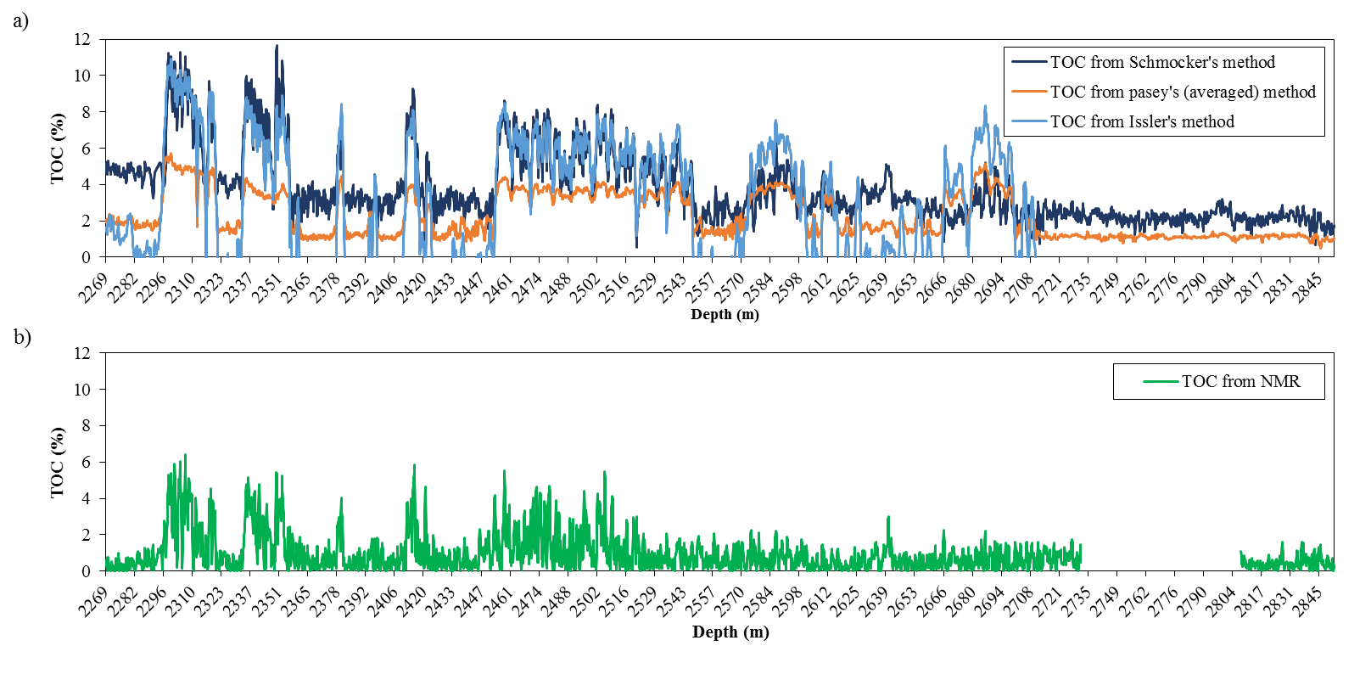
Figure 1
Description of figure 1

Acknowledgements
Acknowledgements must be complete and correct at the time of submission. It should be placed at the end of paper preceding the references. Additions or deletions cannot be made at the proof stage. If the corresponding author wishes to add or delete sponsoring institutions or persons, the paper must be withdrawn, corrected, and resubmitted.

Nomenclature
Nomenclatures should be included in manuscripts in a box when necessary. The following format should be followed:
Abbreviation <Tab>: <Space> Description of the abbreviation
√ Space before and after lines: 0 pt
√ Space after the last line: 0 pt
√ Line spacing: 1.15
√ Alignment: Left
$$Φ_{NMR}$$ | Total NMR porosity
$${HI}_{f}$$ | Hydrogen index of fluid
$$K_{vr}$$ | The kerogen conversion
LOM | Level of maturity
$$ρ_{b}$$ | Bulk density
$$ρ_{f}$$ | Pore fluid density
$$ρ_{k}$$ | Kerogen density
$$ρ_{mg}$$ | Apparent matrix density
$$V_{k}$$ | The kerogen volume
TOC | Total organic carbon

References
References should be addressed by the name of first author, et al. year in brackets (e.g. (Fairbanks, et al. 1971)) in the text and sorted alphabetically at the end of the manuscript without being numbered. It is also substantially recommended to the authors to refer to recent references in last 10 years rather than old and out of date ones. Volume, issue and pages of the whole references must be specified according to the IJOGST format.Authors should refer to the one or more articles published on IJOGST.
√ Time New Roman 11
√ Space before first line: 0 pt
√ Space after second line: 0 pt
√ Line spacing: 1.15
√ Alignment: Justified Low
Journal Papers
Manning, C. E., and Bird, D. K., Porosity evolution and fluid flow in the basalts of the Skaergaard magma-hydrothermal system, east Greenland, American Journal of Science, Vol. 291, No. 1, p. 201-257, 1991.
Theses
Palin, J. M., ms, Stable isotope studies of regional metamorphism in the Wepawaug Schist, Connecticut, Ph.D. thesis, Yale University, New Haven, 170 p. 1992.
Books and Related Publications
McSaveney, M., A manual of weathering-rind dating for sandstone clasts of the Torlesse Super group: 63A, 106 p. Geological Society of New Zealand Miscellaneous Publication., 1992.
Maps
Fritts, C. E., Bedrock geology of the Mount Carmel Quadrangle, Connecticut: United States Geological Survey Quadrangle Map GQ-199, scale 1:24,000., 1963.
Abstracts
Von Huene, R., Forearc highs and backstop structure: EOS, Transactions, American Geophysical Union, Vol. 79, p. F917, 1998.
Table1
Fonts and Font Size in English Abstract
اندازه قلم | اندازه فاصله ها | نام قلم | موقعيت استفاده
14 | Centered  قبل: 18 – بعد: 18 | Times New Roman-Bold | Manuscript Title
11 | Centered  قبل: 6 – بعد: 12 | Times New Roman | Authors Name
10 | Centered  قبل: 0 – بعد: 0 | Times New Roman | Affiliation
12 | Left  قبل: 12 – بعد: 3 | Times New Roman-Bold | Highlight
10 | Left  قبل: 0 – بعد: 10 | Times New Roman | Highlight Text
12 | Left  قبل: 12 – بعد: 6 | Times New Roman-Bold | Abstract
12 | Left  قبل: 6 – بعد: 6 | Times New Roman-Bold | Keywords
11 | Justified  قبل: 6 – بعد: 6 | Times New Roman | Abstract & Keyword Text
12 | Justified  قبل: 12 – بعد: 6 | Times New Roman- Bold | Headers
12 | Justified  قبل: 12 – بعد: 6 | Times New Roman- Bold | Sub header
11 | Justified  قبل: 6 – بعد: 6 | Times New Roman | Text of Manuscript
10 | Centered  قبل: 6 – بعد: 6 | Times New Roman-Bold | Table
10 | Centered  قبل: 0– بعد: 0 | Times New Roman | Text in Table
10 | Left  قبل: 6 – بعد: 6 | Times New Roman-Bold | Figure:
10 | Left  قبل: 6 – بعد: 6 | Times New Roman | Description of Figures
10 | Justified  قبل: 0 – بعد: 0 | Times New Roman | Legend
11 | Justified  قبل: 6 – بعد: 6 | Times New Roman | Reference

